Strategic Marketing Decision Making
QWE Inc Case Study

Assignment 2

Question 1:

The Wall’s belief about the dependence of churn rate on customer age is partially correct. His assumptions on the churn rate of customer age which is less than 6 months and from 6 to 14 months are backed by the data (Figure 1). On the flip side, his assumption on the churn rate of customers who stay with QWE for more than 14 months is not true because the customers who are over 16 months old still remain at a high-risk level. Figure 2 also proves this since the churn rate is an increasing trend.
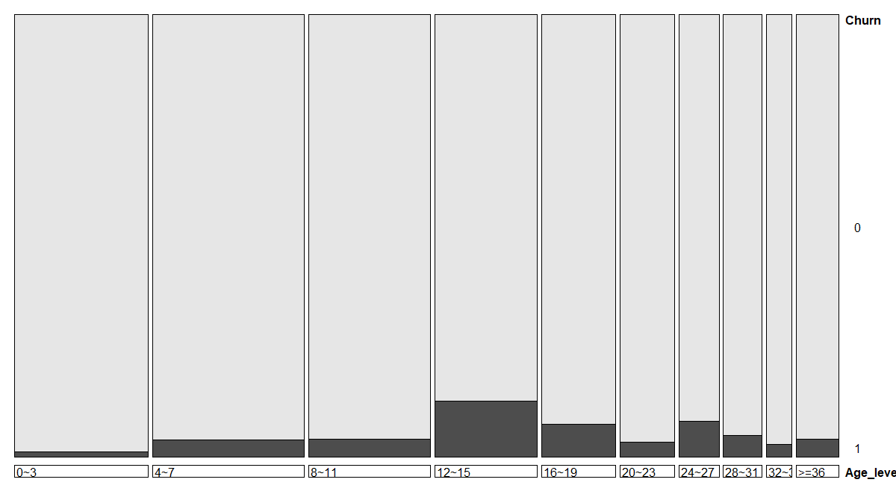
Figure 1: Mosaic plot between Customer Age levels and Churn rate
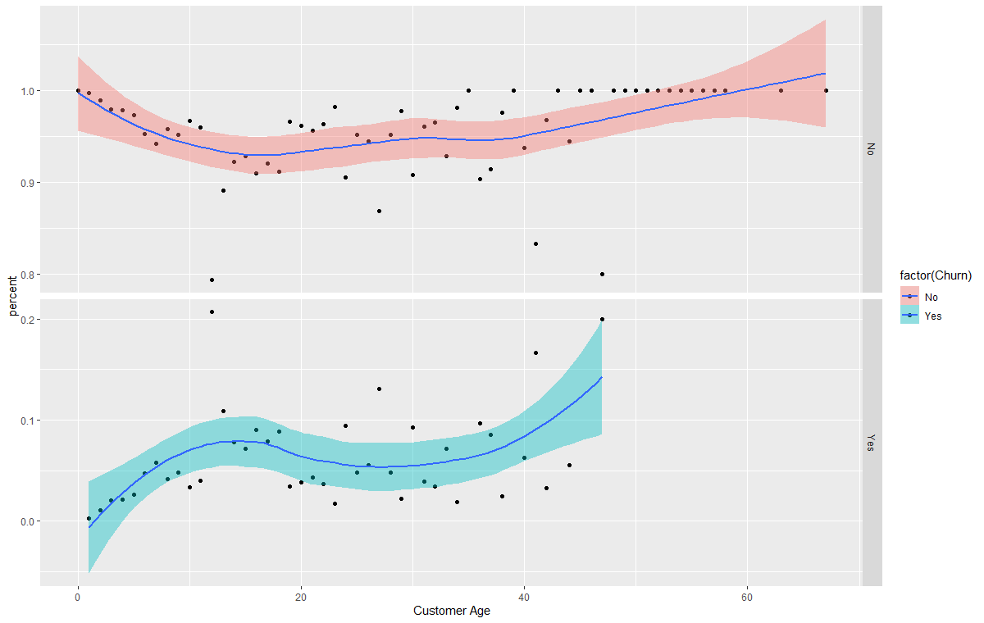
Figure 2: Plot of relationship between Customer Age and Customer Churn rate
Question 2:

Based on this logit regression model, Customer longevity, CHI Score in the current month, CHI score between 1 month (November to December 2011), number of views between 1 month, and the number of days since the last login are the factors that affect the customer churn rate. The longer the customer longevity or the number of days since the last login, the higher the odds of customer churn. Whereas, the higher the CHI score in the current month or the CHI score between 1 month or the number of views, the lower the odds of customer churn.
Specifically, if the customer longevity increases by 1 month and the number of days in the last login increase by 1, the odds of customer churn increase by 1.28% and 1.74% on average respectively. If the CHI score of the current month, the CHI score between 1 month, and the number of views increase by one unit, the odds of customer churn will decrease by 0.46%, 1.03%, and 0.011% on average respectively. However, here the Customer Age could not entirely explain the churn rate variance since they do not have the linear relationship as in Figure 4.
These results might be due to the fact that the happier the customers and the more interactions on the website, the less likely they leave QWE Inc. However, if the customer is inactive for a longer time, it is more likely that he will leave QWE Inc since he might not find QWE’s service useful. In contrast to Walls's reasoning, the impact of the number of support cases, and the numbers of logins, and the number of the blog articles are negligible since if all the cases are resolved, the customers will be satisfied by the technical support capability of the company and the number of blog articles more likely depends on the customer’s operation.
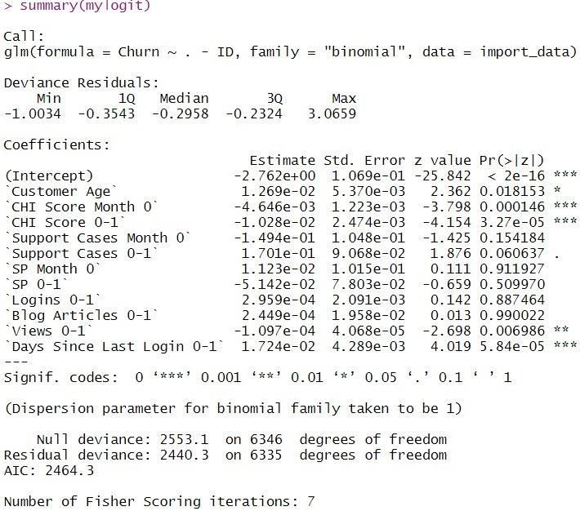
Figure 3: Logit regression model
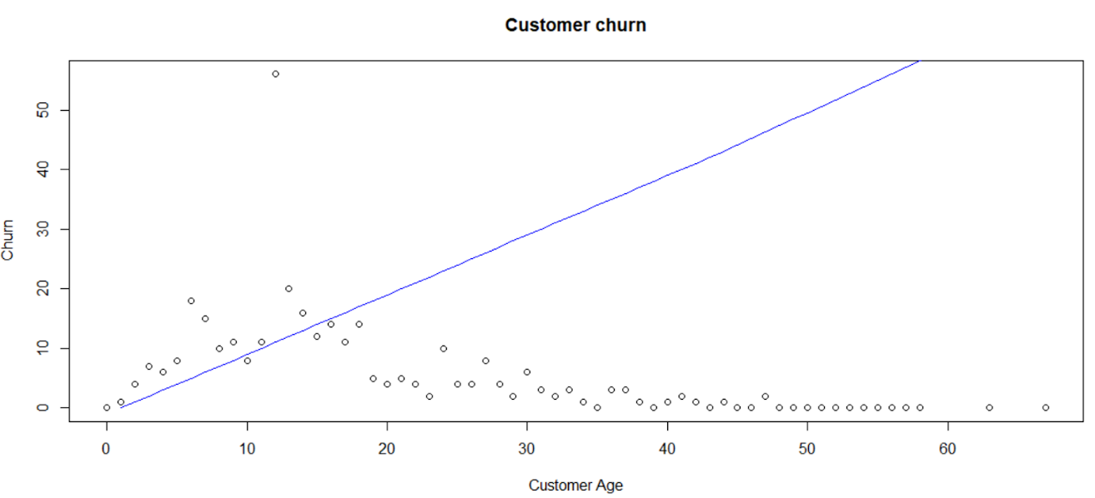
Figure 4: Plot of the relationship between Customer Age and Churn rate

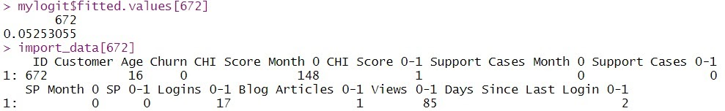
Customer 672 has the predicted probability of 5.25% to leave between December 2011 and February 2012. Though this customer did not actually leave (Churn = 0), this churn rate is slightly higher than the mean churn rate of 5.089%. This might be due to this customer is in the customer age group from 6 to 14 months with the highest churn rate. However, his happiness score is 148 which is much higher than the average CHI score of 87.32.
Figure 5: Prediction of Customer number 672

Customer 354 has the predicted probability of 4.8% to leave between December 2011 and February 2012, though this customer did not actually leave (Churn = 0). Likewise, customer 5203 did not leave even though the predicted probability of leaving for this customer is 4.3%. Both outcomes are slightly lower than the average churn rates of 5.089%.
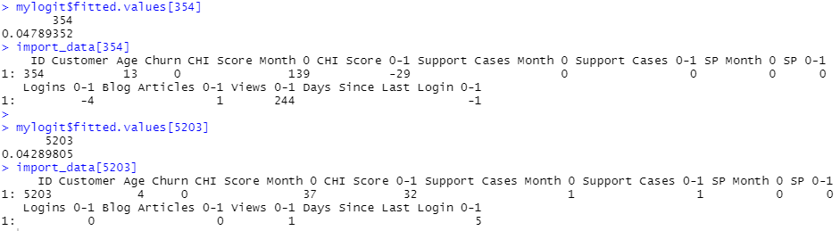
The plausible explanation that impacts the likelihood of customer 354 to leave is due to the age of this customer that belongs to the high-risk group of churning according to Q1. However, the high CHI score in the starting month of the subscription is able to compensate for this risk which confines the effect. This prediction is in line with Q2 that shows a greater significance of CHI score in comparison to customer age. In comparison, customer 3504 does not belong to the risky group of churning. Yet, this customer has a lower CHI score in the starting month of subscription but he/she scores positively in the following month. This customer, in addition, has a longer period of days since last login which contributes to the further increase in probability of this customer to churn.
Figure 6: Prediction of Customer number 354 and 5203

Question 3:

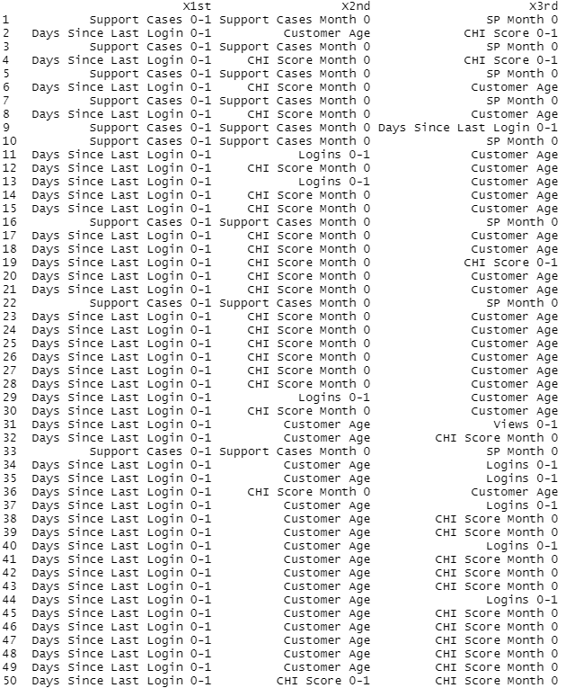
The tables below show the top 100 of the customers with a high probability to churn and the 3 top drivers to do so for each one of them. The drivers with the highest frequency are 1) the number of days since last login, 2) the period being a customer of QWE INC and 3) the customer’s happiness based on the firm's customer happiness index.
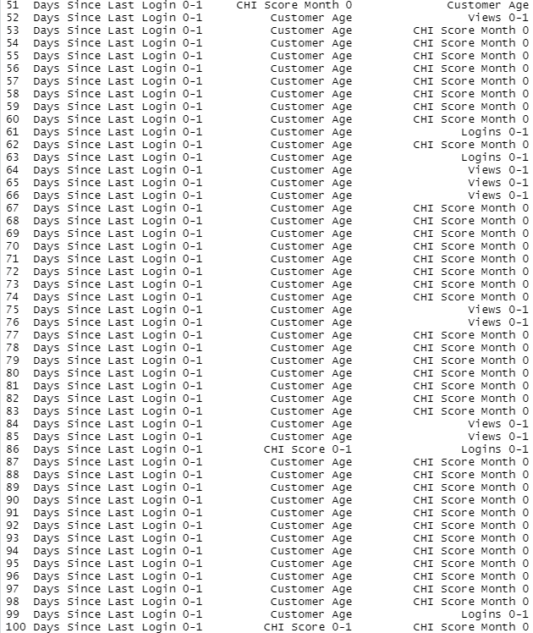
Figure 7: 100 customers with the highest churn probabilities and the top 3 drivers of churn for each customer
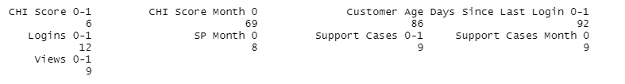
Figure 8: Frequency of each customer churn driver

Customer number 33 in the top 100 list of the customers with a high probability to churn seems to value customer support on the problems that appear when using the firm’s services. The firm should look into it with more care. For example, if support cases appear frequently, then the firm should give some guidance and new tutorials on how to use QWE services. Furthermore, this customer cares about the priority of his support cases as well. The company should put the support cases of this customer higher than usual to meet his needs and preferences.
In the case of Customer number 50 in the top 100 list of the customers with a high probability to churn, the company should focus on changes in his CHI score. When the CHI score appears to be dropping, the firm should contact the customer and ask if they have a problem with the services or make and send them a questionnaire to learn about the problems that appeared recently that drove his CHI to score lower.
Additionally, it seems that the most serious signal of this customer’s probability to leave is the number of days since he or she logged in the services for the last time. So, if this number rises more than usual the company should reach out the customer directly and ask if there is something wrong such as having trouble logging in the services or ask if the needs of the customer have changed and need help on new issues.

